EMPOYEE SCORECARD

This is a complex project which aim was to create a dashboard in Power BI that will provide an overview on employee performance based on specific metrics. The dashboard is taking data from a SQL query, csv files and virtual tables created in Power Query and DAX.

In the dashboard there are hidden filter menus to save space and also DAX measures for calculating the difference between associate performance and average team’s performance.

# DATA SOURCES

## SQL QUERY

The query is providing assigned cases, resolved cases and sent messages for each associate in the team using data from multiple source tables. In the query are used advanced SQL functions such as temporary table and CTE. Query also joins and append the data in order to obtain requested format for the Power BI Dashboard.



## VIRTUAL CALENDAR TABLE IN POWER QUERY

## In order to join the data, filter them and use functions correctly there was a virtual calendar table created in Power Query editor

## 

## VIRTUAL ASSOCIATE TABLE IN DAX

In order to create one global filter for the associate there was a virtual table created using DAX “Summarize” function based on the data from the SQL query.

## OTHER SOURCES

## Other sources are generated text or excel files. These data are cleaned and modified in Power Query editor.

# DATA MODEL

The data were modeled into a snowflake scheme containing fact tables and virtual dimension tables. The dimension tables are Calendar table, Years and Associate.  
The relationships between the tables are shown on the picture below.

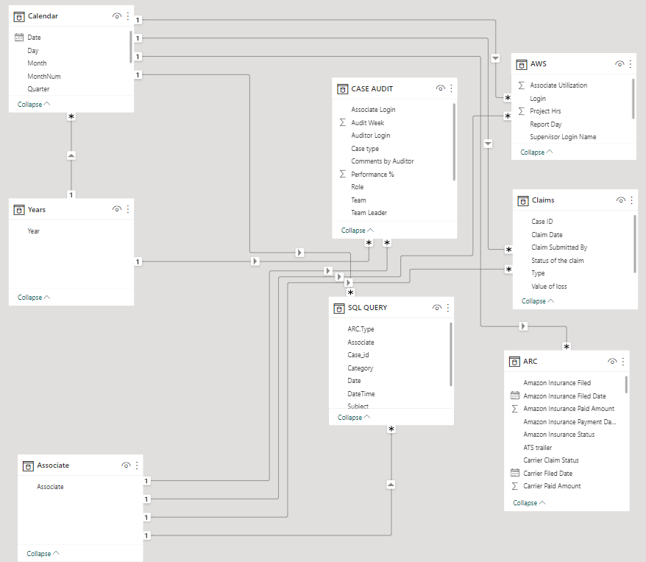

# REPORT – PAGE 1

The page 1 is meant to provide an overview on associate performance. The table visuals contain DAX measures that are comparing the average performance of the team with the performance of each associate.

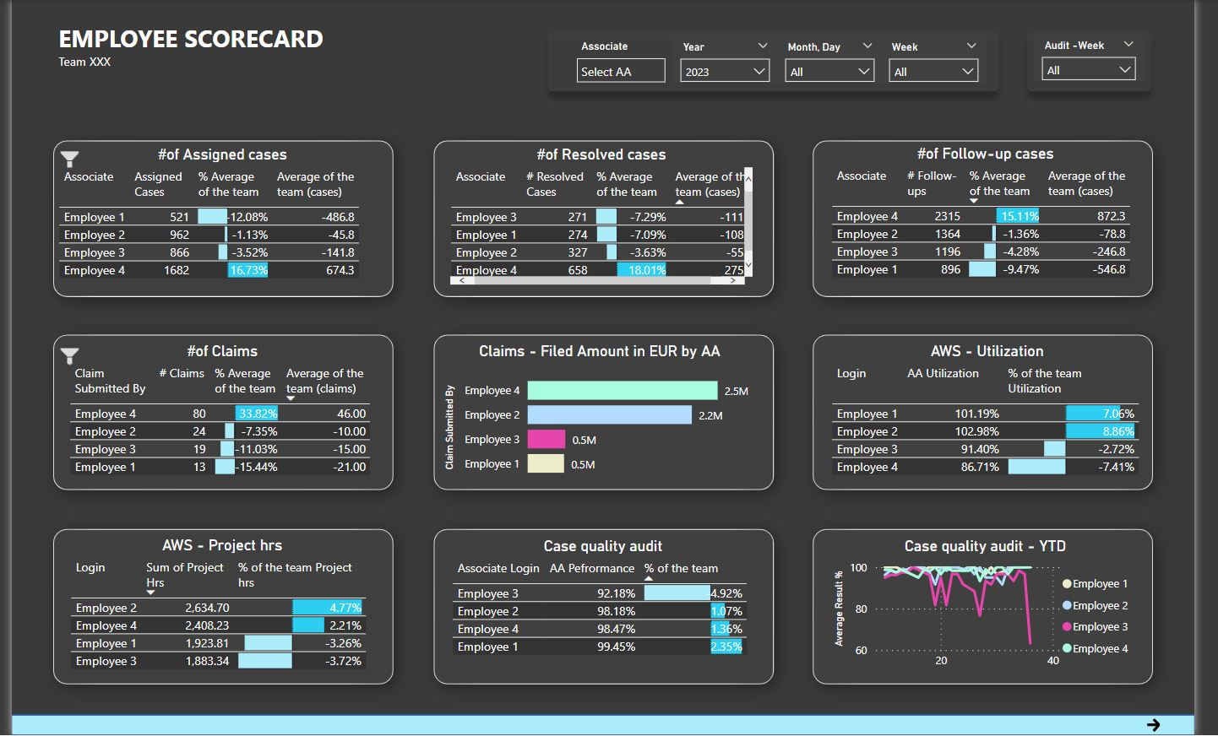

DAX measures are using the CALCULATE function which is allowing to modify the filter context, along with other functions that are keeping the outer context of the applied slicers.

Below is an example of a DAX measure for calculating “Average of the team (cases)”

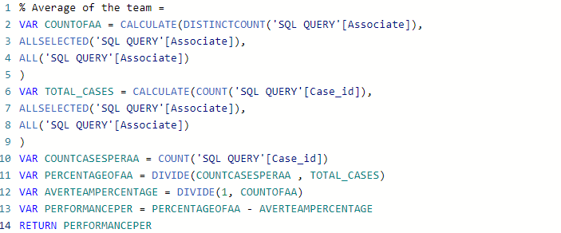

# REPORT – PAGE 2

The page 2 is meant for extracting raw data and performing audits. There are two main tables: “Cases -raw data” and “Claims – raw data” that are allowing the extraction of the data based on the applied slicers.

The table visual “Cases - raw data” can be also filtered by the matrix visual “Case Overview Matrix” when clicking on a specific or multiple values (using Ctrl button).

